Agent-Based Computational Economics:
Building Beyond MinSim
Ye “Cody” Wang
Princeton University, Class of 2010
Department of Computer Science
Adviser: Professor Kenneth Steiglitz

Date: May 4th, 2009

Abstract
Together with Michael Adelson ’11 and Chris Rucinski ’10, under the direction of Professor Steiglitz, we designed and implemented a novel agent-based system for economic simulations, tentatively named “EOS” for “Economics via Object-oriented Simulation.” Building upon previous experience with MinSim [1], EOS was designed from scratch, and introduces a simple, concise set of primitive types with well-defined abstractions for interactions among these types; one important feature of the design is its extensibility and flexibility, easily allowing others to design a wide variety of new types of objects and simulations. We demonstrate this flexibility by implementing some basic economic simulations using the baseline EOS framework. We were able to simulate the effects of basic price controls on the performance of our agent classes; in particular, we explored the effect of price floors in a simple labor market (for example, representing a minimum wage law). An analysis of these results shows promise for our ability to successfully reproduce real-world economic phenomena within EOS. Further work in extending EOS could be done to allow more complex economic interactions, vis-à-vis contract formation and execution, as well as implementing other types of market clearing mechanisms; by its very nature however, it is hard to specify precisely what should be done in the future for EOS, given its inherently open-ended design.
1. Introduction
Introduction to Agent-based Systems
By the term “agent” in agent-based systems, we take the general definition given by Tesfatsion in [2] as “bundled data and behavioral methods representing an entity constituting part of a computationally constructed world.” In that sense, agent-based systems have been used to perform experiments in a variety of fields, from “simulation of economies, societies and biological environments,” since they offer a tremendous amount of flexibility and greater accuracy in replicating real-world phenomena in many cases [3]. In general then, agent-based simulations are dynamically driven by interacting agents, whose individual behavior is algorithmically defined in their respective data types; however, the overall behavior of the system is not (and for the most part, can not be) dictated by artificial, external, or global control mechanisms. Or as LeBaron and Leigh Tesfatsion put it in [4], “modelers do not need to constrain agent interactions a priori by the imposition of equilibrium conditions, homogeneity assumptions, or other external coordination devices that have no real-world referents.”
In economics in particular, agent-based modeling provides a powerful and flexible alternative to more traditional methods of simulation, where complex real-world phenomena that may be impossible to recreate from the “bottom-up” are instead simplified and then defined a priori from the “top-down,” often using theoretical closed-form solutions to replicate the desired parameters and behavior. “The implicit assumption is that the simplification process has spared all relevant elements and discarded only unnecessary ornaments” [5]. However, this is often not the case, since the determination of what constitutes an “unnecessary ornament” can be rather uncertain, and so ironically the results of such simulations are inherently constrained by their initial definitions and inputs. Thus, “to study the dynamical properties of the system,” we must turn to an agent-based approach.
Project Background
This desire for an agent-based approach to economics has previously taken the form of the MinSim project (developed by Chris Chan ’08 and extended by Daniel Hayes-Patterson ’09, as described in [6] , [7], and [8]); it built on ideas developed earlier by Professor Steiglitz and others in [9]. MinSim was so named because it attempted to simulate a “minimally complete” economy, in the sense that the basic building blocks of a modern economy (producers, consumers, traders, banks, lending, investment, etc.) would all be replicated to some extent. However, the implementation of MinSim was found to be unstable a significant amount of the time, and so it was decided early on in this project to move beyond MinSim to build a more generalized framework for agent-based economic simulation.
Motivation and Goals for EOS
Thus, our initial goal for “EOS” was to leverage the experiences of building MinSim, so that we could build a general framework for agent-based economic simulation, with well-defined, natural abstractions for describing economic scenarios that would allow others to easily extend the baseline functionality of EOS in the future. MinSim had been a fairly complex system, with many rigidly defined interactions between agents, and given its instability, we felt that it was necessary to carefully redesign the basic primitives of EOS so as to be extensible, flexible, and easily comprehensible. Our plan was to layout what the basic structure of EOS would be (described in the following section), then implement a simple baseline simulation to demonstrate how simple types of agent behaviors could be modeled under such a framework; we also hoped to be able to also run some interesting economic experiments, once we had achieved a stable simulation. Specifically, the focus of this paper in terms of economic experiments was on the influence of price floors in the Labor markets (these “Goods” and their corresponding “Markets” are discussed in sections (2) and (3)).
2. EOS Design Overview
Design Primitives
The fundamental design of EOS focused on what we perceived to be the three most primitive and natural components of essentially all economies: Agents, Markets, and Goods. Other classes exist in order to drive the simulation, such as an “Economy” container class that holds references to all the elements in the simulation world, and a “Simulation” class that drives the simulation with a step() method and that also has various reporting/data output methods. However, the focus is on the three Agent, Market, and Good primitives, which we feel are the signature feature of EOS; since they are relatively easy to explain, and straightforward to implement, we feel that this design makes the problem of extending EOS to cover a variety of different types of simulations much easier. For our purposes, the use of the term “Agent” as opposed to “agent” will refer specifically to the primitive data type as defined by EOS (and similarly for “Market” and “Good”).
Agents
Agent is the term we apply to any economic actor that is capable of actively performing some action during each time-step of the simulation; in EOS, all Agents also possess the ability to own Goods (more on this in the “Goods” section). In essence, an Agent represents a decision-making actor, and as such can be an abstraction for anything ranging from an individual worker to a corporation to a state/government entity. An Agent’s decision-making will focus primarily on their bidding behavior in the various Markets that exist for each Good (more on this in the “Markets” section), though in the future, non-market actions such as taxation, or contract-making/enforcing may also play a major role in EOS. Agent is a framework-level abstract class, and all actors in the simulation will extend Agent or subclasses of Agent.
Markets
Markets are an abstraction representing a place in which Agents can exchange Goods through the placing of buy and sell bids. Currently, each Market is built around a specific, unique “product-currency” pair; that is to say, every Market must declare one Good to be the product being traded, and another Good being the currency that is used to pay for that product (hence, Money is one type of Good we have defined; see the “Goods” section for details). However, there are no restrictions on what kinds of Goods can be currency, so even barter- systems could be modeled by arbitrarily declaring one to be the “currency” for a particular Market; this has no effect outside the Market, as all Goods are treated equally, unless some Agents apply an individual distinction in valuation (e.g. an experimenter may want to see what happens when a specific type of Agent values Food twice as much as Money). Currently, all of our transactions occur in a sealed-bid call-auction market, which is defined by its market-clearing behavior of setting a market-clearing for all Agents in the Market such that trade volume is maximized (as described in [9]), however essentially any type of market-clearing mechanism can be used so long as it is able to fulfill the bids of Agents on various Goods in a systematic way.
Goods
In many ways, Goods and how Agents and Markets deal with Goods represent the most interesting part of any economic model. In our case, EOS defines a Good as simply some commodity that can be owned and thus traded by Agents in Markets. Currency is not treated in any special way; any Good could be passed to a Market as its currency, but within the scope of our simulation we define a Money class that all Agents and Markets treat as the only currency. Thus, each Agent maintains a reference to an individual list of that includes an instantiated object representing every available type of Good in the given simulation world; this represents the Goods which that Agent happens to own. Importantly, each Good object’s only meaningful field is its quantity; thus, if Farm A bids to sell 5 units of its Food on the Food-Money Market and Farm B bids to sell 5 units of its Food, these are different object references, but to Market and to other Agents, these are indistinguishable from each other. This abstraction is necessary and natural for modeling actions on basic, generic economic commodities (food, labor, money, etc.); it is possible that future versions of EOS will include distinguishable Goods (e.g. using the previous example, Farm A’s Food may be of better quality than Farm B’s).
Framework Structure
Given these basic primitives then, the structure of EOS looks somewhat like this:
Framework
SimpleLaborer
Agent
Market
Good
Economy
Firm
Laborer
Farm
DiscreteGood
ContinuousGood
BaselineEconomy
SimpleFarm
CallAuctionMarket
Food
Labor
Money
The Baseline Code
Models
Strategy
Fig. 1: From preliminary EOS documentation, unpublished (by Michael Adelson).
The top-level framework classes are the classes we discussed just prior to this section; there are then “model-level” classes that extend the basic framework, to define the general rules which those specific types will follow (i.e. a DiscreteGood “is-a” type of Good, and can only be traded or consumed/produced in discrete quantities, or a Laborer “is-a” type of Agent that represents an individual who sells his Labor for Money and buys Food to consume). At the bottom are “strategy-level” classes that extend the model-level classes; these define precisely how each type of object should behave (i.e. SimpleLaborer “is-a” Laborer, and defines a simple set of algorithms for implementing its actual bidding behavior).
3. Baseline Simulation Overview
Having collaboratively designed the basic structure for the EOS framework and laying out the desired structure for simulations to take under EOS, we began by implementing a baseline simulation that would demonstrate some simple, reasonable economic phenomena. We based this upon some of the basic components of the original “food-gold model” in [9], but also made significant changes to those original abstractions. We chose to model individuals (Laborers), who consumed a certain amount of Food per time-step and would “die” (i.e. exit the simulation) if they ran out of Food, and Farms that would hire Laborers and pay them to produce Food, which the Farms would then sell to the Laborers (in the appropriate Food-Money and Labor-Money Markets). In this way, Laborers would have to work in order to earn enough money to buy Food; for simplicity, it was assumed that Farms incurred no cost each time-step to operate (whether or not Labor was hired or Food was produced). Our initial goal was merely to produce a stable simulation, so no arbitrary determination of value exists (i.e. it is not better in any external sense to have more Money or more Food, outside of the corresponding increase in likelihood of survival).
Our baseline implementation would thus have the following Agents, Markets, and Goods:
Agents: SimpleLaborer, SimpleFarm, and (optionally) SimpleTrader
Markets: Food-Money, Labor-Money
Goods: Food, Labor, Money
SimpleLaborer extended Laborer, and represented one individual who consumed a certain amount of food each time-step, and could buy Food and/or sell Labor. Its behavior was designed to do little more than survive; the bids it submitted to each Market were determined based on the previous market-clearing price and its current quantity of Food on hand. SimpleFarm extended Farm which extended Firm, and represented a type of business (“Firm”) that was specifically a “Farm” that could buy Labor and use it to produce Food; it bought Labor through an estimation of profitability based on the previous market-clearing prices. SimpleTrader, which was added later, was a Firm that could buy and sell Food and Labor in the respective Markets; it would attempt to “buy low” and “sell high” in both Markets.
Development Stages
At this point, it should be noted that a significant amount of time was spent writing, rewriting, debugging, and standardizing code that had little to do with actual economic simulation. For example, mechanisms such as the call-auction market are fairly complex, and initial implementations had several bugs in border cases. Furthermore, standardizing the specific format of class APIs (after deciding on the general framework structure) and also deciding what information would be available to Agents and Markets and Goods, as well as how to pass that information, were all fairly time-consuming. However, since they do not relate to the fundamental economic simulations, we mention these issues here only to point out the difficulty in trying to build such an ambitious framework from scratch; the amount of time spent on these types of basic “grunt-work” tasks thus limited the amount of time available to experiment with and implement complex Agent behaviors and simulations.
Our next step was to try to produce a stable simulation, where Agents would bid somewhat more intelligently on both Food and Labor. Similar to how workers bid in MinSim, we decided Laborers would attempt to bid higher prices for food as their quantity of food on hand decreased. Likewise, if Laborers became low on Money, they would lower their prices for Labor in an attempt to increase their chances of being hired by a Farm. The Farm would buy Labor as before, but would try to sell as much of its Food as possible since it derived no benefit from keeping a large store of Food on hand (granted, not selling Food would not hurt the Farm in anyway, but it would obviously cause other Agents to starve). Traders would attempt to buy Goods at below the last market-clearing price, and sell them at above that price.
Initial implementations along these lines had Agents making only a single bid in most cases. This was found to be too rigid, as Laborers and Farms would quickly settle into a steady-state equilibrium where the cost of Food and Labor were equal and constant (see “Simulation (1)”). Instead, we decided to have Agents submit a range of bids, for discrete quantities of Goods at a variety of prices, thereby ensuring that most of the time, at least some of an Agent’s bids would be cleared. Variations on this behavior, where some Agents submitted a range of bids representing a demand or supply curve with reasonable pricing behavior (with the notable exception of Traders, who continued to make only “single-shot” bids), resulted in long-term equilibrium states being reached (that is, production and price levels settled into fixed behavior; see “Simulation (2)” in the following section).
One final note: with more intelligent Agents who used exponential smoothing to assign an estimate of value to each Good and therefore tried to take advantage of Market conditions, variability was introduced into these stable systems, so that production and price-levels would fluctuate periodically (see Simulation 3). Not all Agents in a simulation had to make use of this smoothing for variability to arise (in fact, only the Farm is performing any smoothing in Simulation 3). By exponential smoothing, we mean the following, similar to the method laid out in [9]:
,
where is the value of a given Good at the -th time-step, is the smoothing factor, and is the last market-clearing price.
4. Individual Contributions
So far, we have outlined the process by which the baseline framework for EOS was collaboratively designed. In terms of the discussion and critique of the early design and implementation phases, all group members contributed equally to EOS. Thus, this section serves to outline my concrete, specific individual contributions to the coding of EOS as well as experiments I performed (discussed in “Simulation Results”), since it would be near impossible to quantify contributions in any other way.
I created the first implementation of the framework structure, using random bidding behavior for Agents, while adhering to the basic design primitives of EOS. I began with a rough implementation where each Agent simply bid randomly at each time-step, as a way of testing out the call market implementation, as well as to observe what basic behavior would be like such a system. Obviously the economy collapsed fairly quickly, but not before a significant amount of bids were made and cleared on both Markets; all Laborers would begin the simulation with enough Food to survive for 10 time-steps before starving (assuming no Food was bought and no Labor was sold) but even the random simulation was able to last for roughly 30-50 time-steps. This stage, though seemingly trivial, is significant because (like all agent-based simulations), there was no external guarantee that any trades at all would occur. Each Agent simply behaved according to its own internally defined set of rules for bidding, and through the Market, was able to interact with other autonomous Agents.
I then implemented a Trader class that would attempt to buy as much Food as possible given its current amount of Money at the last market-clearing price, while attempting to sell as much Food as it has on hand at a random premium above the last market-clearing price (from [100%, 200%) of the last market-clearing price). This Trader would die if it ever became bankrupt. In early simulations, this served to support the economy by becoming a secondary source of Food for Agents who were “starving.” However, this behavior ultimately proved to be too simplistic to be of much additional interest, and so more advanced Trader classes was used later on.
I also created the TheoryFarm class, which modified SimpleFarm’s default behavior by placing sell bids for its Food inventory along a linear parameterized supply curve. Combining this with the TheoryLaborer class, we were able to achieve a stable equilibrium state (see “Simulation (2)”) after some tweaking of initialization parameters for various Agents. This was a significant stage because prior to this, the only steady-state equilibrium we had been able to achieve were equivalent to “Simulation (1)”, where SimpleFarm and SimpleLaborer’s essentially “settled” on a 1-to-1, Food-to-Labor price that neither would deviate from.
Finally, I independently explored the various effects of wage controls as well as unemployment statistics in Labor Markets. For the most part, these simulations relied on the baseline “Simulation (3)” behavior, with the necessary tweaks (such as imposing a minimum price in the clearing mechanism for the Market, when enforcing a price floor) to support the simulation.
5. Baseline Simulation Results
This section will describe the results of various simulations conducted in EOS, by detailing the types of Agents used, their behavior algorithms, and various other parameters of the simulation. All simulations have exclusively Food, Labor, and Money as their only Goods, and also only employ a call auction market; unless otherwise stated, all simulations start with 10 Laborers and 1 Farm.
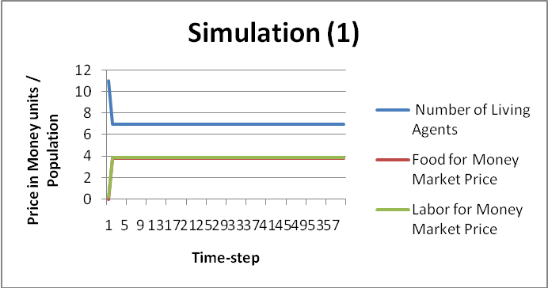
Simulation (1): SimpleLaborer and SimpleFarm
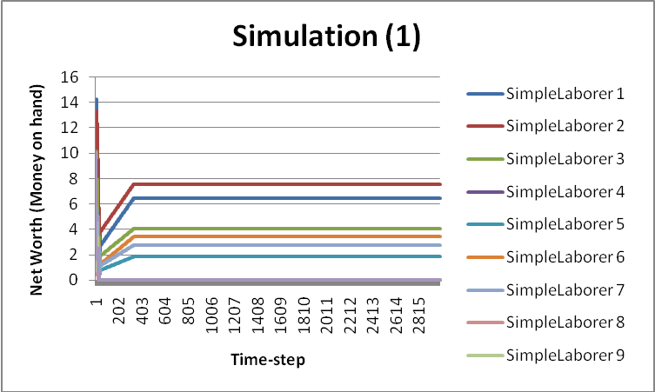
This is one of the most basic stable simulations, using only SimpleLaborer’s and SimpleFarm. Food and Labor prices are randomly seeded in the first time-step, then the market quickly reaches a 1-to-1 ratio of Food-per-unit-Money to Labor-per-unit-Money (in essence, the cost of Food is equal to the cost of Labor, which is why the lines on the graph overlap). While some SimpleLaborer’s die prior to this steady-state equilibrium, the remaining ones will survive indefinitely. This equilibrium is due to the simple bidding behavior of both classes, which is basically tied to the last market-price, so that once steady-state is reached, neither class attempts to “break” from it. Also, it is worth noting that adding SimpleTrader (implemented as a Laborer type) to this system does not affect its long-term steady-state behavior (presumably because the Trader either dies off fairly quickly).
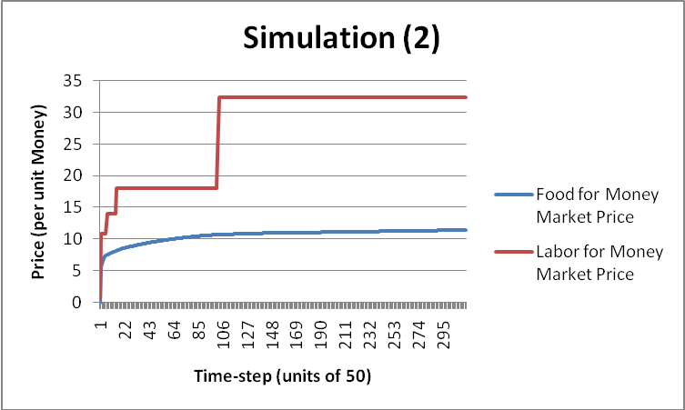
Simulation (2): TheoryLaborer and TheoryFarm
This simulation uses the TheoryLaborer and TheoryFarm classes, whose main difference with their “Simple” equivalents is that they will use certain linear parameters to generate multiple bids along supply and demand curves (note that TheoryFarm and SimpleFarm share the same bidOnLabor() function, since we felt that this was really the only logical way for the Farm to bid on Labor).
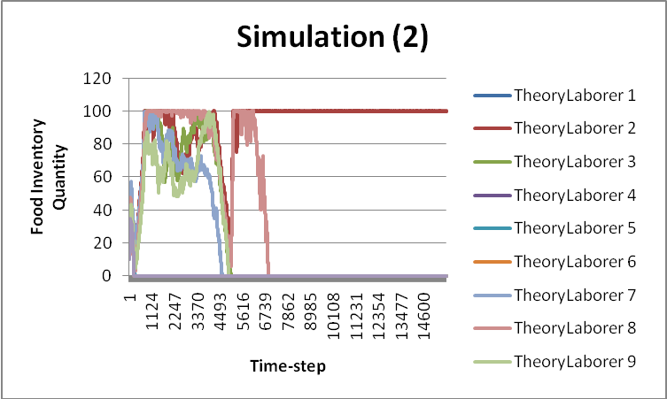
The equilibrium state for this simulation is not a steady-state one, as we can see that the price of Food is slowly increasing (the price of Labor is constant in each segment). We can verify however that this is indeed an equilibrium state by examining the amount of Food that the TheoryLaborer’s possess (note that the surviving TheoryLaborer does not actually have a constant amount of Food, but the periodic increases and decreases are all so small as to be impossible to notice on such a graph). Again, adding a Trader to this simulation had no noticeable long-term affect. Also not shown is the amount of Money possessed by the surviving Laborer, but like its Food quantity, its Money quantity fluctuates only slightly and remains basically constant. In any case, this simulation seems to result in a basic form of inflation, in the price of Food.
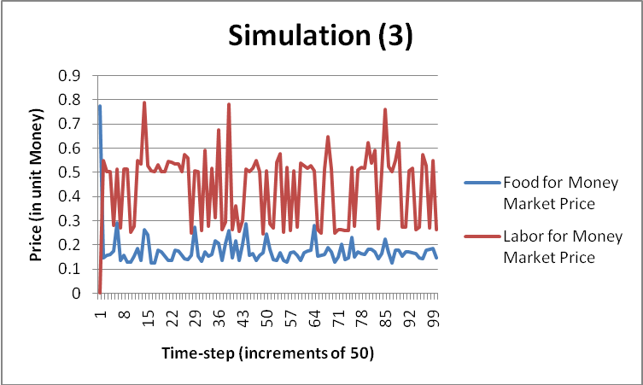
Simulation 3: SimpleLaborer2 and SimpleFarm2

With the introduction of exponential smoothing on the part of the Farm, dubbed SimpleFarm2, this simulation was finally able to achieve long-term stability with dynamic price variations. Note that the SimpleLaborer2 class does not perform any smoothing. Again, adding a Trader into the system does not result in any significant changes. However, we do consider this simulation to be fundamentally representative of a simple multi-laborer, single-farm economy, so that we can move on to our price control experiments.
6. Price Control Simulations
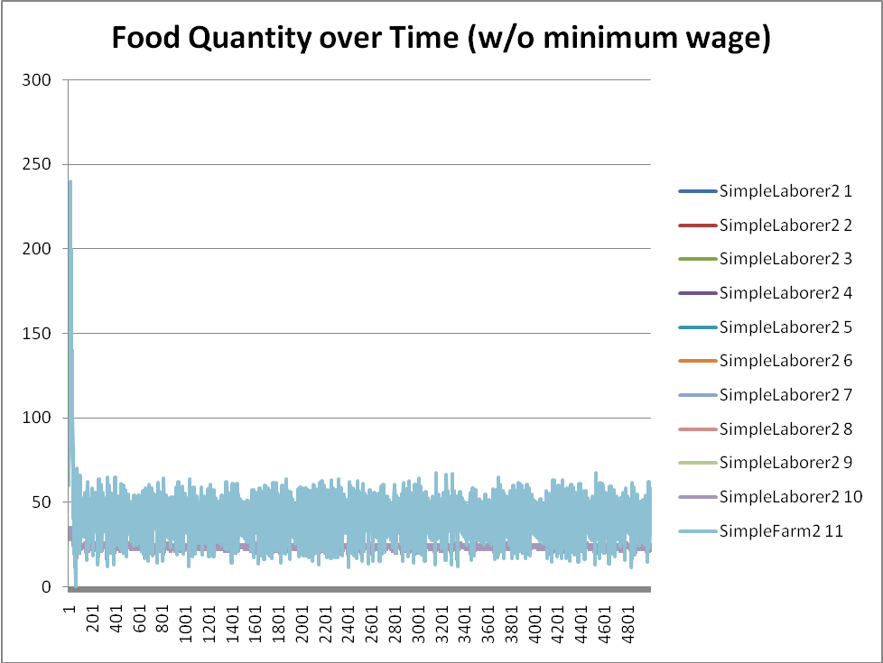
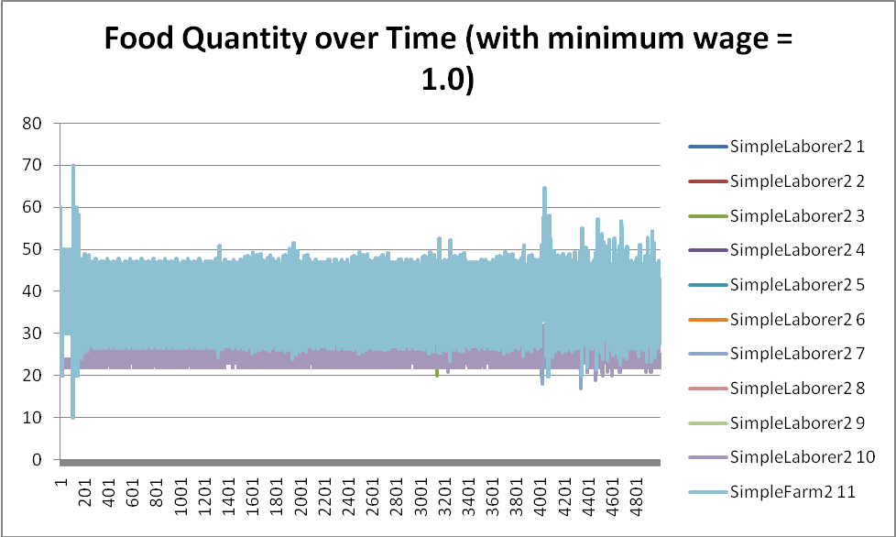
Having collaboratively developed a suitable simulation, I then focused on what effects price controls might have on the Labor Market, as well as residual effects on the economy as a whole. First, we note that due to the exponential smoothing and initial seed of prices in both Markets from [0, 1) that prices are almost never higher than 1.0 in either market. Hence, I decided to begin with setting a minimum wage of 1.0 in the Labor market. I implemented this in the call-auction market’s clearing mechanism, so that if the market-clearing price would have been set at below the minimum wage, I then reset the market-clearing price to be the minimum wage price. Below are some representative results, comparing the graphs for the baseline simulation with no minimum wage, and the simulation with minimum wage = 1.0:
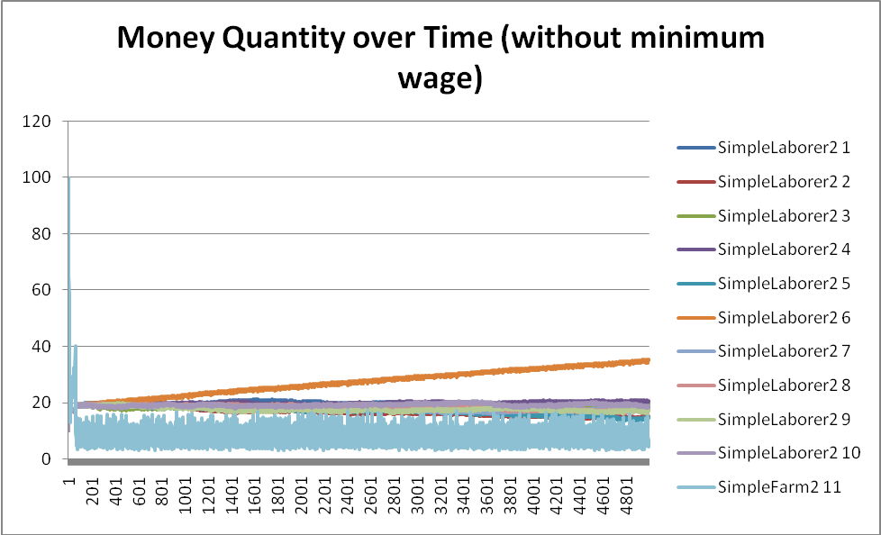
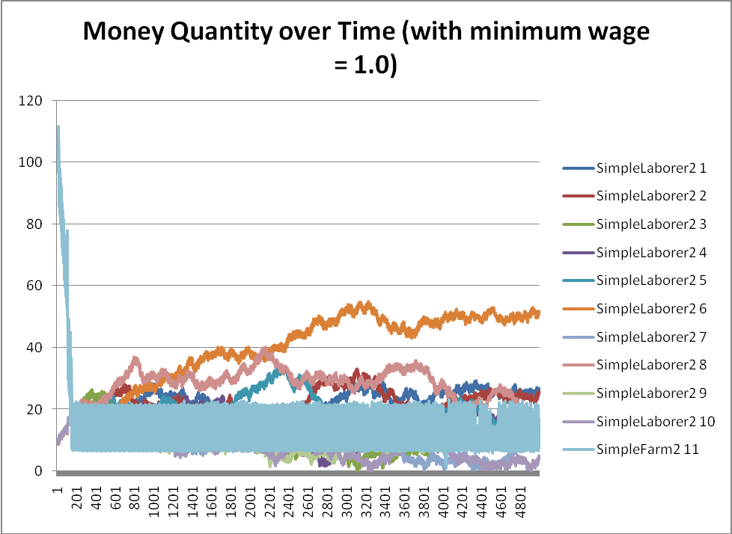
(Notice that the average amount of Food appears to be lower on the right)
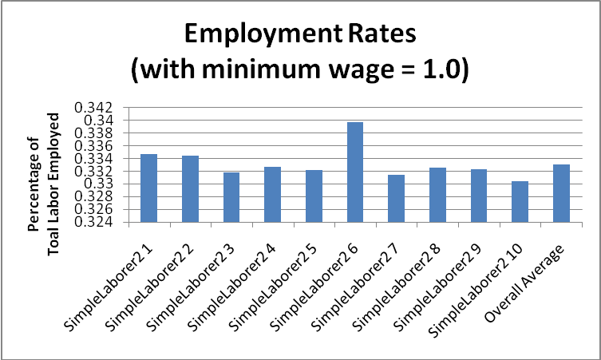
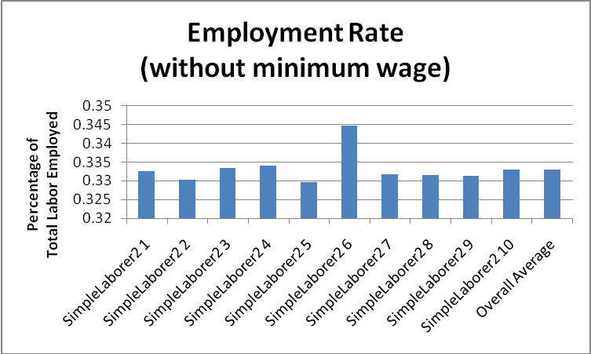
(Notice that this graph is much more volatile with a minimum wage in place)

(Nearly identical graphs, for employment rates)
I then doubled the minimum wage to 2.0, with similar results (employment rates stayed nearly constant, at just over 33%), though the graph of Money quantity was even more volatile. At a minimum wage of 2.5 or higher, the simulation seems to always collapse within the first 50 time-steps; this specific value of 2.5 is most likely related to the choice of input parameters (for example, the farm’s production function), but it is highly probable that there will always exist a limit for high enough minimum wages such that the economy will collapse. When I reran simulations with 15 SimpleLaborer2’s and 1 Farm (and no minimum wage), the economy achieved long-term stability with an average employment rate of again roughly 33%. Imposing a minimum wage of 1.0 on this system again had roughly the same effect.
7. Analysis of Simulations
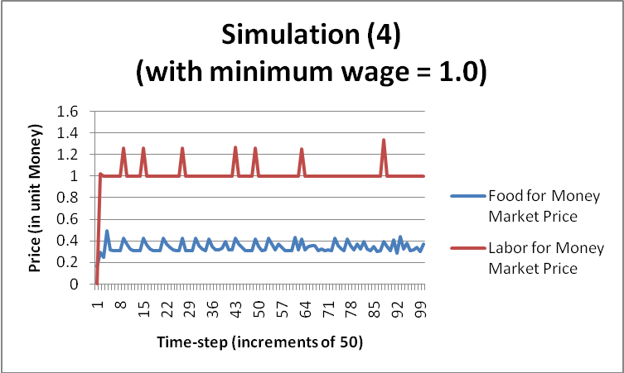
We presume this means that so long as the Farm is able to comfortably support the Laborers in the simulation world, imposing a relatively low minimum wage does not adversely affect the economy, other than moderate inflation, as evidenced by the graph on the right.
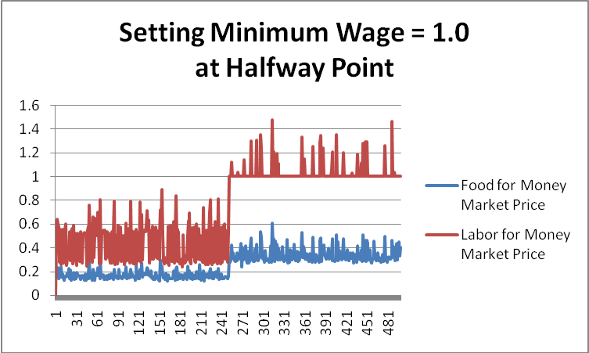
We have thus demonstrated that setting a minimum wage will cause some measure of inflation, as the price of Food increases after the introduction of a minimum wage (even at the halfway point in a simulation). This seems reasonable to us, and one would expect to see similar behavior in the real world, in response to an increase in the minimum wage. Plenty of research exists that supports the notion that raising the minimum wage will introduce inflationary pressures on an economy (as in [10]).
Of more interest is the hiring practices of the Farm, since it does not seem to be affected by increases in the minimum wage, at least not until it has reached a completely unsustainable point. Obviously, this has as much to do with the fact that the Farm in our simulation is the only source of Food as it does with Farm’s bidding behavior; by being the sole seller of Food, the Farm has enormous power to dictate prices, which Laborers will accept if they are desperate/hungry enough. That being said, the low employment rate of roughly 33% seems strangely low, given that the Farm in our simulations has been given a fairly generous production function, so that it can support a large number of laborers by producing significantly more than 1 unit of Foor per 1 unit of Labor . However, even with only 4 Laborers, the Farm still only employs them about 1/3 of the time. Most likely this is because the Laborers in the system cannot afford to buy up as high volume of Food as the Farm is capable of producing, so that the price for Food stays fairly low, which means it is not profitable to hire too much Labor.
8. Related Work
Comparing EOS to existing agent-based computational economics (ACE) tools, we generally find EOS to be much easier to understand from a design perspective. By focusing on only 3 key primitives, we really feel that this reduces the barrier for others to extend EOS in the future. For example, Swarm is an example of a fairly well-supported, open-source approach to agent-based simulation. It was originally written mostly in Objective-C and Tcl/Tk, and with a goal of becoming “a common language to those economists who already employ simulations as one of their tools of analysis” [5]. However, because it is built to be a general purpose simulation system, it tends towards being overly cumbersome to deploy quickly, and forces many abstractions upon the experimenter (e.g. having to create an “observer swarm” as a superset of the underlying “model swarm,” which in turn defines agents’ behaviors and schedules). By contrast, EOS allows one to flexibly choose how to divide their agent’s taxonomy, with well-defined guidelines for where certain types of code should go; likewise, EOS also forces the experimenter to have clear mental picture of what each segment of her simulation really represents in order to design the most efficient and useful abstractions for use in EOS.
Other examples of different approaches to agent-based simulation include the ACE Trading World example laid out by Tesfatsion in [2], where the agents must handle “determination of terms of trade…, seller-buying matching…., rationing…, trade…, settlement…, profit allocation…, and shakeout.” With EOS, instead of listing each of these as individual activities that need to be handled, the EOS framework handles them in clear, concise ways (i.e. seller-buyer matching, trade, and settlement are all inherent parts of the Market abstraction). Similarly, the other activities naturally fall into the hands of each individual agent to deal with. We believe that examples such as this one abound in economic simulations (MinSim was even an example of this), where an experimenter must design many separate components to handle each individual action or aspect of a simulation. In contrast, EOS provides a structure to aid experimenters in pigeon-holing exactly where each component of a simulation belongs.
9. Conclusions and Further Work
Designing EOS from the ground up, we learned several lessons which we could apply in the future. First and foremost is that it is hard to design an open-ended framework that is both limited in scope enough to be meaningful but still open to extension. We feel that the basic abstractions of Agents, Markets, and Goods will cover the vast majority of economic interactions, and thus the vast majority of actions that can be simulated in an experiment. Not only does it easily allow for implementation of an experiment, but EOS also helps experimenters to clarify the structure of their experiment and its dependencies, by taking advantage of its intuitive structure.
Even with the simplistic experiments which we were able to implement, we were able to observe behavior that mirrored real-world phenomena. Our Agents were designed so as to be signaled only by the price of Goods in the Market; this is the only piece of external piece of information to which an Agent has access to, in addition to information about its own state. Thus, we consider our simulation to be rather elegant, because of this frugality of information. It successfully represents dynamic, limited-information economic interaction where actors have access to only a small set of data in making their decisions. Already we have observed complex behavior arising from the fairly simple set of rules which we used to define our Agents, Markets, and Goods; furthermore, our simulation has already behaved in ways that could not have been readily predicted a priori. We feel that this was a successful demonstration of the power of agent-based simulation, as well as the flexibility of the EOS framework.
In the future, we hope to extend EOS to cover more complex interactions, in addition to the basic per-time-step actions of bidding in markets. Specifically, we feel that contracts are a necessary feature; without a concise definition of contract fornation and execution, we do not believe that complex multi-step interactions can be implemented. Furthermore, we have barely scratched the surface of what is possible in terms of agent behaviors; our algorithms are all rather deterministic, and do not make use of information from previous interactions beyond the minimal amount of exponential smoothing that occurs in Farms and Traders. Implementing learning agents would certainly improve the representative accuracy of simulations. Likewise, our methods for determining a supply or demand curve for a given agent are straightforward linear functions; obviously in the real world, agents would have a wide variety of these curves and so it would be extremely helpful to implement a generalized way to submit arbitrary supply or demand curves for a given agent.
The ultimate goal perhaps is to turn EOS into a powerful sort of “scripting” language for describing economic interactions. Experimenters might be able to create their own agents simply by choosing functions from an existing library of different pre-defined behavior rule-sets and algorithms. To our knowledge, no current system exists with that kind of functionality.

Honor Code statement:
This paper represents my own work in accordance with University regulations.

- Ye Wang
References

[1] Hayes-Patterson, D. ’09. “MinSim Documentation.” 2008. <http://MinSim.cs.princeton.edu/documentation.htm>.

[2] Tesfatsion, L. “Agents come to bits: Towards a constructive comprehensive taxonomy of economic entities.” Journal of Economic Behavior & Organization. Vol. 63 (2007), pg. 333-346.

[3] Luck, M. “50 facts about Agent-Based Computing.” AgentLink III. 2005. <http://www.econ.iastate.edu/tesfatsi/AgentLink.50CommercialApplic.MLuck.pdf>.

[4] LeBaron, B. and Tesfatsion, L. “Modeling Macroeconomics as Open-Ended Dynamic Systems of Interacting Agents.” AEA Papers & Proceedings. May 2008, to appear. <http://www.econ.iastate.edu/tesfatsi/AEAPP2008.LeBaronTesfatsion.ACEMacroModeling.Final.pdf>

[5] Stefansson, B. and Luna, F. Economic Simulations in Swarm: Agent-based Modeling and Object Oriented Programming. Advances in Computational Economics, Vol. 14. New York: Springer, 2000.

[6] Chan, C. ’08. “Part I: A Java Library Implementation of the Gold-Fold Economic Model in Repast and MASON.” Jan. 7, 2008. <http://MinSim.cs.princeton.edu/resources/ChrisChan_IW_2008_Part1.pdf>.

[7] Chan, C. ’08. “Part II: An Agent-Based Model of a Minimal Economy.” May 5, 2008. <http://MinSim.cs.princeton.edu/resources/ChrisChan_IW_2008_Part2.pdf>.

[8] Hayes-Patterson, D. “Introducing Traders to an Agent-Based Minimal Economy: Creating a Platform for Collaborative Research in Economic Agent-Based Simulation.” Jan. 5, 2009. <http://MinSim.cs.princeton.edu/resources/dhayesThesisFINAL.doc>.

[9] Steiglitz, K., Honig, M. L., and Cohen, L. M. “A Computational Market Model Based on Individual Action.” S. Clearwater (Ed.): Market-Based Control: A Paradigm for Distributed Resource Allocation. Hong Kong: World Scientific, 1996.

[10] Gramlich, Edward M. “Impact of Minimum Wages on Other Wages, Employment, and Family Incomes.” 1976. Brookings Papers on Economic Activity (No. 2): 409-461.
Appendix A: Source files
SimpleLaborer.java:
package agents;

import java.util.Map;

import framework.Economy;
import framework.Good;
import framework.Market;
import models.*;
import java.util.Random;

public class SimpleLaborer extends Laborer{

/**
* If the laborer has this amount of food, then it feels fairly certain that
* it will survive for the foreseeable future and so does not bid very much
*/
private final double FOOD_THRESHOLD = EAT_AMOUNT * 20.0;

/**
* Constructor
*/
public SimpleLaborer(Economy economy, Map<String, Good> goods) {
super(economy, goods);
}

/**
* bids on labor and food
*/
protected void bid() {
bidOnLabor();
bidOnFood();
}

/**
* Always bid the market price for food; if none exists, bid a random number between 0 and
* LABOR_ALLOWANCE
*/
private void bidOnLabor() {

Market laborMarket = economy.getMarketFor(money.getClass(), labor.getClass());
Market foodMarket = economy.getMarketFor(money.getClass(), food.getClass());

double lastPrice = foodMarket.getLastMarketPrice();
while (lastPrice <= 0.0) {
lastPrice = new Random().nextDouble();
}
laborMarket.addSellOffer(money, labor, labor.getQuantity(), lastPrice);

}

/**
* Don't bid if the amount of food is greater than FOOD_THRESHOLD. Otherwise, bid for
* a quantity of EAT_AMOUNT. Bid a price that linearly increases to the amount of
* money on hand, reaching it when the laborer has no food left.
*/
private void bidOnFood() {

Market foodMarket = economy.getMarketFor(money.getClass(), food.getClass());
/**
* Bid nothing if the agent feels it has enough food already
*/
if (food.getQuantity() >= FOOD_THRESHOLD) {
return;
}
if (money.getQuantity() <= 0.0) {
return;
}

double quantity = EAT_AMOUNT;
double price = -(money.getQuantity() / FOOD_THRESHOLD) * food.getQuantity() + money.getQuantity();

foodMarket.addBuyOffer(money, food, quantity, price);

}

}
SimpleFarm.java
package agents;

import java.util.Map;
import java.util.Random;

import framework.Economy;
import framework.Good;
import framework.Market;
import models.*;

public class SimpleFarm extends Farm {

/**
* the increments in which the farm bids on labor
*/
private final double DISCREET_LABOR_BID = 0.3;

/**
* the farm keeps bidding on labor until the expected revenue
* falls below this amount
*/
private final double MIN_REVENUE = 0.1;

/**
* Create a new Firm in economy.
*/
public SimpleFarm(Economy economy, Map<String, Good> goods) {
super(economy, goods);
}

/**
* bid on labor and sell goods
*/
protected void bid() {
bidOnLabor();
bidOnFood();
}

/**
* Bid on labor by creating a demand curve for it, using the previous market
* price of food to calculate expected revenue from the hired labor
*/
private void bidOnLabor() {

Market laborMarket = economy.getMarketFor(money.getClass(), labor.getClass());
Market foodMarket = economy.getMarketFor(money.getClass(), food.getClass());

double lastFoodPrice = foodMarket.getLastMarketPrice();
while (lastFoodPrice <= 0.0) {
lastFoodPrice = new Random().nextDouble();
}

double i = DISCREET_LABOR_BID;

/**
* Offer bids until the farm runs out of money or the expected revenue gets too low.
* This basically creates a demand curve for labor that gets its downward slope from
* the diminishing returns of convertFoodToLabor()
*/
while (true) {

double foodToProduce = convertToFood(i) - convertToFood(i - DISCREET_LABOR_BID);
double expectedRevenue = foodToProduce * lastFoodPrice;
if (expectedRevenue < MIN_REVENUE) {
break;
}
if (expectedRevenue > money.getQuantity()) {
break;
}
double unitPrice = expectedRevenue / DISCREET_LABOR_BID;
laborMarket.addBuyOffer(money, labor, DISCREET_LABOR_BID, unitPrice);

i += DISCREET_LABOR_BID;

}

}

/**
* Bid the last price of food
*/
private void bidOnFood() {

if (food.getQuantity() <= 0.0) {
return;
}

Market foodMarket = economy.getMarketFor(money.getClass(), food.getClass());

double lastPrice = foodMarket.getLastMarketPrice();

while (lastPrice <= 0.0) {
lastPrice = new Random().nextDouble();
}

foodMarket.addSellOffer(money, food, food.getQuantity(), lastPrice);

}
}
SimpleTrader.java
package agents;

import java.util.Map;

import framework.Economy;
import framework.Good;
import framework.Market;
import models.Laborer;

public class SimpleTrader2 extends Laborer {

/**
* When food quantity is below the threshold the laborer bids more than
* the market price and vice versa.
*/
private static final double FOOD_THRESHOLD = 30;

/**
* Constant used in exponential smoothing.
*/
private static final double ALPHA = 0.1;

/**
* The economy's food and labor for money markets.
*/
private Market foodMarket;

/**
* An exponentially smoothed estimate of the value of food.
*/
private double value;

/**
* Create a new SimpleTrader
*/
public SimpleTrader2(Economy economy, Map<String, Good> goods) {
super(economy, goods);
foodMarket = null;
}

/**
* The trader buys food for himself using the same method as SimpleLaborer2.
* He then uses the rest of his money/food to buy low and sell high.
*/
protected void bid() {

// update labor's state
//System.out.println("Trader: " + this.getID() + " food: " + food.getQuantity() + " money: " + money.getQuantity());

// update value of food
if (foodMarket == null) { // initialize
foodMarket = economy.getMarketFor(money.getClass(), food.getClass());
value = Math.random() + 1e-3;
} else value = ALPHA*foodMarket.getLastMarketPrice() + (1 - ALPHA)*value;

// bid for self using SimpleLaboerer2's technique
if (foodMarket.getLastMarketPrice() <= 0.0) {
foodMarket.addBuyOffer(money, food, EAT_AMOUNT, Math.random() + 0.05);
foodMarket.addBuyOffer(money, food, EAT_AMOUNT, Math.random() + 0.05);
return;
}

double quantity = 2.0 * EAT_AMOUNT;
double price = foodMarket.getLastMarketPrice()
* (FOOD_THRESHOLD / (food.getQuantity() + 0.1));
if (price * quantity > money.getQuantity())
price = money.getQuantity() / quantity;

if (price >= 0.0)
foodMarket.addBuyOffer(money, food, quantity, price);

// buy low
price = 0.95 * value;
quantity = money.getQuantity() / price;
if (quantity > 0.0)
foodMarket.addBuyOffer(money, food, quantity, price);

// sell high
price = 1.25 * value;
quantity = food.getQuantity() - FOOD_THRESHOLD;
if (quantity > 0.0)
foodMarket.addSellOffer(money, food, quantity, price);
}

}
TheoryFarm.java
package agents;

import java.util.Map;
import java.util.Random;

import framework.Economy;
import framework.Good;
import framework.Market;
import models.*;

public class TheoryFarm extends Farm {

/**
* y-intercept for Food supply curve, as ratio of last market price
*/
private final double FOOD_START_PRICE_RATIO = 1.1;

/**
* the increments in which the farm bids on labor
*/
private final double DISCRETE_FOOD_BID_QUANTITY = 0.2;

/**
* the increments in which the farm bids on labor
*/
private final double DISCREET_LABOR_BID = 0.2;

/**
* the farm keeps bidding on labor until the expected revenue
* falls below this amount
*/
private final double MIN_REVENUE = 0.1;

/**
* Carrying capacity, in terms of an amount of food
*/
private final double CARRY_CAPACITY = 10.0;

/**
* Create a new Firm in economy.
*/
public TheoryFarm(Economy economy, Map<String, Good> goods) {
super(economy, goods);
}

/**
* bid on labor and sell goods
*/
protected void bid() {
bidOnLabor();
bidOnFood();
}

/**
* Bid on labor by creating a demand curve for it, using the slope constant
* and a pre-defined abstraction of the y-intercept being twice the market price
*/
private void bidOnLabor() {

Market laborMarket = economy.getMarketFor(money.getClass(), labor.getClass());
Market foodMarket = economy.getMarketFor(money.getClass(), food.getClass());

double lastFoodPrice = foodMarket.getLastMarketPrice();
while (lastFoodPrice <= 0.0) {
lastFoodPrice = new Random().nextDouble();
}

double i = DISCREET_LABOR_BID;

/**
* Offer bids until the farm runs out of money or the expected revenue gets too low.
* This basically creates a demand curve for labor that gets its downward slope from
* the diminishing returns of convertFoodToLabor()
*/
while (true) {

double foodToProduce = convertToFood(i) - convertToFood(i - DISCREET_LABOR_BID);
double expectedRevenue = foodToProduce * lastFoodPrice;
if (expectedRevenue < MIN_REVENUE) {
break;
}
if (expectedRevenue > money.getQuantity()) {
break;
}
double unitPrice = expectedRevenue / DISCREET_LABOR_BID;
laborMarket.addBuyOffer(money, labor, DISCREET_LABOR_BID, unitPrice);

i += DISCREET_LABOR_BID;

}
}

/**
* Bid to sell food beginning at current quantity of food on the supply curve,
* and essentially moving up and to the left
*/
private void bidOnFood() {

double currentFoodAmount = food.getQuantity();

// don't bid to sell food, if no food available
if (currentFoodAmount <= 0.0) {
return;
}

Market foodMarket = economy.getMarketFor(money.getClass(), food.getClass());
double lastFoodPrice = foodMarket.getLastMarketPrice();

// random initial 0 to 1 seed for lastFoodPrice
while (lastFoodPrice <= 0.0) {
lastFoodPrice = new Random().nextDouble();
}

int numTotalBids = (int) (currentFoodAmount / DISCRETE_FOOD_BID_QUANTITY);

// slope for supply curve defined such that at quantity = carrying capacity,
// price is last market price
double slope = -(FOOD_START_PRICE_RATIO * lastFoodPrice - lastFoodPrice) / currentFoodAmount;

double currentFoodBidPrice = (slope * currentFoodAmount) + (FOOD_START_PRICE_RATIO * lastFoodPrice);
double bidIncrement = ((FOOD_START_PRICE_RATIO * lastFoodPrice) - (currentFoodBidPrice)) / numTotalBids;

for(int i = 0; i < numTotalBids; i++) {
if(currentFoodBidPrice > 0) {
foodMarket.addSellOffer(money, food, DISCRETE_FOOD_BID_QUANTITY, currentFoodBidPrice);
currentFoodBidPrice += bidIncrement;
}
}

}

}
TheoryLaborer.java
package agents;

import java.util.Map;

import models.Laborer;
import framework.Economy;
import framework.Good;
import framework.Market;

public class TheoryLaborer extends Laborer{

/**
* used to determine the demand curve for food that this laborer submits in
* the form of bids
*/
private final double FOOD_THRESHOLD = EAT_AMOUNT * 100.0; // 100.0 worked?

/**
* used to determine the supply curve for labor that this laborer submits in
* the form of bids
*/
private final double LABOR_THRESHOLD = LABOR_ALLOWANCE * 0.7;

/**
* used to discretize supply/demand curves into discrete bids
*/
private final double DISCRETE_LABOR_UNIT = 0.2;
private final double DISCRETE_FOOD_UNIT = 0.2;

/**
* Constant used in exponential smoothing.
*/
private static final double ALPHA = 0.1;

/**
* The economy's food and labor for money markets.
*/
private Market foodMarket, laborMarket;

/**
* An exponentially smoothed estimate of the value of labor.
*/
private double value, foodValue;

/**
* Constructor
*/
public TheoryLaborer(Economy economy, Map<String, Good> goods) {
super(economy, goods);
foodMarket = null;
laborMarket = null;
}

/**
* bids on labor and food
*/
protected void bid() {
// update value of food
if (laborMarket == null) { // initialize
laborMarket = economy.getMarketFor(money.getClass(), labor.getClass());
foodMarket = economy.getMarketFor(money.getClass(), food.getClass());
// estimate initial value randomly up to 20% of money on hand
value = (money.getQuantity()/5.0)*Math.random() + 1e-3;
// estimate initial food value randomly up to 5% of money on hand
} else {
value = ALPHA*laborMarket.getLastMarketPrice() + (1 - ALPHA)*value;
foodValue = ALPHA*foodMarket.getLastMarketPrice() + (1 - ALPHA)*foodValue;
}

bidOnLabor();
bidOnFood();
}

/**
* bid the market price for labor until the labor allowance, then bid more according to
* the slope from the origin to the intersection of the market price and labor threshold
*/
private void bidOnLabor() {

Market laborMarket = economy.getMarketFor(money.getClass(), labor.getClass());

double laborPrice = laborMarket.getLastMarketPrice();

while (laborPrice <= 0.0) {
laborPrice = Math.random();
}

laborMarket.addSellOffer(money, labor, LABOR_THRESHOLD, laborPrice);
double slope = laborPrice / LABOR_THRESHOLD;

while(labor.getQuantity() > 0) {
double quantity = Math.min(DISCRETE_LABOR_UNIT, labor.getQuantity());
laborPrice += slope * quantity;
laborMarket.addSellOffer(money, labor, quantity, laborPrice);
}

}

/**
* using the food threshold and the market price to determine the linear, negatively
* sloping demand, bid according to the intersection of current food with the demand
* curve and downwards for each subsequent unit of food. the demand curve we use is
* such that the most a laborer will bid is twice the current market price, which has
* the nice property that the laborer will only ever bid on enough food to fill twice
* the threshold amount.
*/
private void bidOnFood() {

//can't bid if we don't have money
if (money.getQuantity() <= 0.0) {
return;
}

Market foodMarket = economy.getMarketFor(money.getClass(), food.getClass());
double lastPrice = foodMarket.getLastMarketPrice();

while (lastPrice <= 0.0) {
lastPrice = Math.random();
}

for (double i = food.getQuantity(); i < 2 * FOOD_THRESHOLD && money.getQuantity() > 0; i += DISCRETE_FOOD_UNIT) {

double price = 2 * lastPrice - (lastPrice / FOOD_THRESHOLD) * i;
if (price <= 0.0) {
break;
}
foodMarket.addBuyOffer(money, food, DISCRETE_FOOD_UNIT, price);

}

}

}
SimpleFarm2.java
package agents;

import java.util.Map;

import framework.Economy;
import framework.Good;
import framework.Market;
import models.Farm;

public class SimpleFarm2 extends Farm {

/**
* the increments in which the farm bids on labor
*/
private static final double DISCREET_LABOR_BID = 0.2; // used to be 1.0

/**
* the farm keeps bidding on labor until the expected revenue
* falls below this amount
*/
private static final double MIN_REVENUE = 0.1;

/**
* If the farm has more than this amount of food, it will lower it's
* asking price. If it has less, it will raise it.
*/
private static final double FOOD_THRESHOLD = 60.0;

/**
* Alpha used in exponential smoothing.
*/
private static final double ALPHA = 0.1;

/**
* The exponentially smoothed value estimate for food.
*/
private double value;

/**
* The economy's food and labor for money markets.
*/
private Market foodMarket, laborMarket;

/**
* Create a new DemandCurveFarm in economy.
*/
public SimpleFarm2(Economy economy, Map<String, Good> goods) {
super(economy, goods);
foodMarket = null;
laborMarket = null;
}

/**
* bid on labor and sell food.
*/
protected void bid() {

// update value of food
if (foodMarket == null) { // initialize
foodMarket = economy.getMarketFor(money.getClass(), food.getClass());
laborMarket = economy.getMarketFor(money.getClass(), labor.getClass());
value = Math.random() + 1e-3;
} else value = ALPHA*foodMarket.getLastMarketPrice() + (1 - ALPHA)*value;

bidOnLabor();
bidOnFood();
}

/**
* Bid on labor by creating a demand curve for it, using the estimated
* market price of food to calculate expected revenue from the hired labor.
*/
private void bidOnLabor() {
double i = DISCREET_LABOR_BID;

/**
* Offer bids until the farm runs out of money or the expected revenue gets too low.
* This basically creates a demand curve for labor that gets its downward slope from
* the diminishing returns of convertFoodToLabor()
*/
while (money.getQuantity() > 0.0) {

double foodToProduce = convertToFood(i) - convertToFood(i - DISCREET_LABOR_BID);
double expectedRevenue = foodToProduce * foodMarket.getLastMarketPrice();
if (expectedRevenue < MIN_REVENUE) {
break;
}
if (expectedRevenue > money.getQuantity()) {
expectedRevenue = money.getQuantity();
}
double unitPrice = expectedRevenue / DISCREET_LABOR_BID;

laborMarket.addBuyOffer(money, labor, DISCREET_LABOR_BID, unitPrice);

i += DISCREET_LABOR_BID;

}

}

/**
* Set food prices based on quantity and historic market price.
*/
private void bidOnFood() {

// cannot sell food
if (food.getQuantity() <= 0.0) {
return;
}

/* if lastPrice = 0, sell food at various prices, effectively "probing"
* the Laborer's demand curves. */
if (foodMarket.getLastMarketPrice() <= 0.0) {
double maxBids = 30, Qf = food.getQuantity();
for (double d = 0; d < maxBids; d++)
foodMarket.addSellOffer(money, food, Qf/d, Math.random() * value);
return;
}

// else adjust price based on the farm's quantity of food
double price = value;
price *= FOOD_THRESHOLD/food.getQuantity();

foodMarket.addSellOffer(money, food, food.getQuantity(), price);

}

}
SimpleLaborer2.java
package agents;

import java.util.Map;

import framework.*;
import models.Laborer;

public class SimpleLaborer2 extends Laborer {

/**
* A comfortable stock of food.
*/
private static double FOOD_THRESHOLD = 30;

/**
* Food and Labor Markets
*/
private Market foodMarket, laborMarket;

/**
* Construct a new SimpleLaborer2
*/
public SimpleLaborer2(Economy economy, Map<String, Good> goods) {
super(economy, goods);
foodMarket = null;
laborMarket = null;
}

/**
* Bid on labor and food.
*/
protected void bid() {

if (foodMarket == null) { // initialize
foodMarket = economy.getMarketFor(money.getClass(), food.getClass());
laborMarket = economy.getMarketFor(money.getClass(), labor.getClass());
if (foodMarket == null || laborMarket == null)
throw new RuntimeException("Economy must have food/money and labor/money markets");
}

bidOnLabor();
bidOnFood();
}

/**
* Bid on labor.
*/
private void bidOnLabor() {
if (foodMarket.getLastMarketPrice() <= 0.0) {
laborMarket.addSellOffer(money, labor, LABOR_ALLOWANCE, 2.0 * Math.random() + 0.1);
return;
}

double price = 2.0 * foodMarket.getLastMarketPrice()
* (food.getQuantity() / FOOD_THRESHOLD)
* (EAT_AMOUNT / LABOR_ALLOWANCE);
if (price <= 0.0) return;
laborMarket.addSellOffer(money, labor, LABOR_ALLOWANCE, price);
}

/**
* Bid on food.
*/
private void bidOnFood() {
if (foodMarket.getLastMarketPrice() <= 0.0) {
foodMarket.addBuyOffer(money, food, EAT_AMOUNT, Math.random() + 0.05);
foodMarket.addBuyOffer(money, food, EAT_AMOUNT, Math.random() + 0.05);
return;
}

if (money.getQuantity() <= 0.0) return;

double quantity = 2.0 * EAT_AMOUNT;
double price = foodMarket.getLastMarketPrice()
* (FOOD_THRESHOLD / (food.getQuantity() + 0.1));
if (price * quantity > money.getQuantity())
price = money.getQuantity() / quantity;

foodMarket.addBuyOffer(money, food, quantity, price);

}

}

A note on stability: used in this context, stability refers to the long-term, non-degenerate survival and continuing interaction of a minimally interesting set of agents. Of course, if a given simulation does not allow for agents to “die,” or if degeneracy is a non-trivial result (i.e. the experimenter learns that setting minimum wage levels too high causes an economy to collapse), then the definition of stability is slightly altered in those contexts.
In regards to the step() method, it was felt that a simple, global “clock tick” system would be the easiest with which to begin implementing simulations. However, there is no logical reason why other simulation classes could be designed that could function asynchronously, with or without a clock, so long as the relevant Agents are implemented in a corresponding manner.
We shall refer to markets following this convention, i.e. the Food-Money Market is the Market where the product Food is bought and sold using the currency Money.
These and other source files are included in Appendix A.
The decision was made later on that adding “traders” who represented Firms that did not produce or consume any Goods but rather would just trade in Markets might improve the stability of the simulation.
There are actually two implementations of Traders; my original version of a Trader extended Firm, while the later version extended Laborer. This second version of Trader was thus subject to dying when it ran out of Food, making its trading in the Food Market problematic.
http://www.swarm.org

